*Use the information in Chapter 17 (p.325-348) to answer the following questions about gene expression. You may also find the following Bozeman podcasts useful:* [*DNA & RNA Part 2*](http://www.bozemanscience.com/027-part-2-dna-rna)*,* [*Mutations*](http://www.bozemanscience.com/mutations)*.*

**Concept 17.1: Genes Specify Proteins via transcription & translation**

1. Explain what is meant by the central dogma in terms of the directional flow of genetic information.
2. Use Figure 17.3 (p.329) to compare and contrast the flow of genetic information in prokaryotes and eukaryotes.

|  |  |  |
| --- | --- | --- |
| Prokaryotes | Both | Eukaryotes |
|  |  |  |

1. Explain how the flow of information from gene to protein is based on a triplet code. You may want to include a diagram to help with your explanation.
2. Use the following template strand of DNA to draw the mRNA sequence and the polypeptide sequence using the codon chart in Figure 17.5. Label the start and stop codon and explain the significance of each.

3’-TACAGTCGTATT-5’

1. Use the following complimentary strand of DNA that would pair with the above sequence in #4 (this would be the non-template strand) to draw the mRNA sequence and the polypeptide sequence using the codon chart in Figure 17.5. Compare this final transcript with the one made using the template strand.

5’-ATGTCAGCATAA-3’

**Concept 17.2: Transcription is DNA-directed synthesis of RNA**

1. Describe the three major phases of transcription illustrated in Figure 17.7 (p.332).

* Initiation
* Elongation
* Termination

1. Use Figure 17.8 (p.333) to describe how transcription is initiated at a eukaryotic promoter.



1. Describe the function of RNA polymerase during the elongation phase of transcription (Figure 17.9).

**Concept 17.3: Eukaryotic cells modify RNA after transcription**

1. Summarize the major modifications that are made to RNA during eukaryotic RNA processing. Include labeled diagrams to help your explanation.

* Alteration of mRNA ends
* RNA splicing

1. Produce labeled diagram that shows an mRNA strand that has underwent processing in a eukaryotic cell (Figure 17.10).
2. Explain the functional and evolutionary importance of introns.

**Concept 17.4: Translation is the RNA-directed synthesis of a polypeptide**

1. Draw and label a molecule of tRNA (Figure 17.15 - a or c). Describe the shape that it takes shown in (a) and explain its function in translation.
2. Describe the function of the enzyme aminoacyl-tRNA. Does it carry out exergonic or endergonic reactions?
3. Draw and label the structures of a ribosome (Figure 17.17 - b).
4. Describe how the initiation of translation begins (Figure 17.18).
5. Use the diagram below to summarize the process of elongation during translation. Are these reactions exergonic or endergonic?

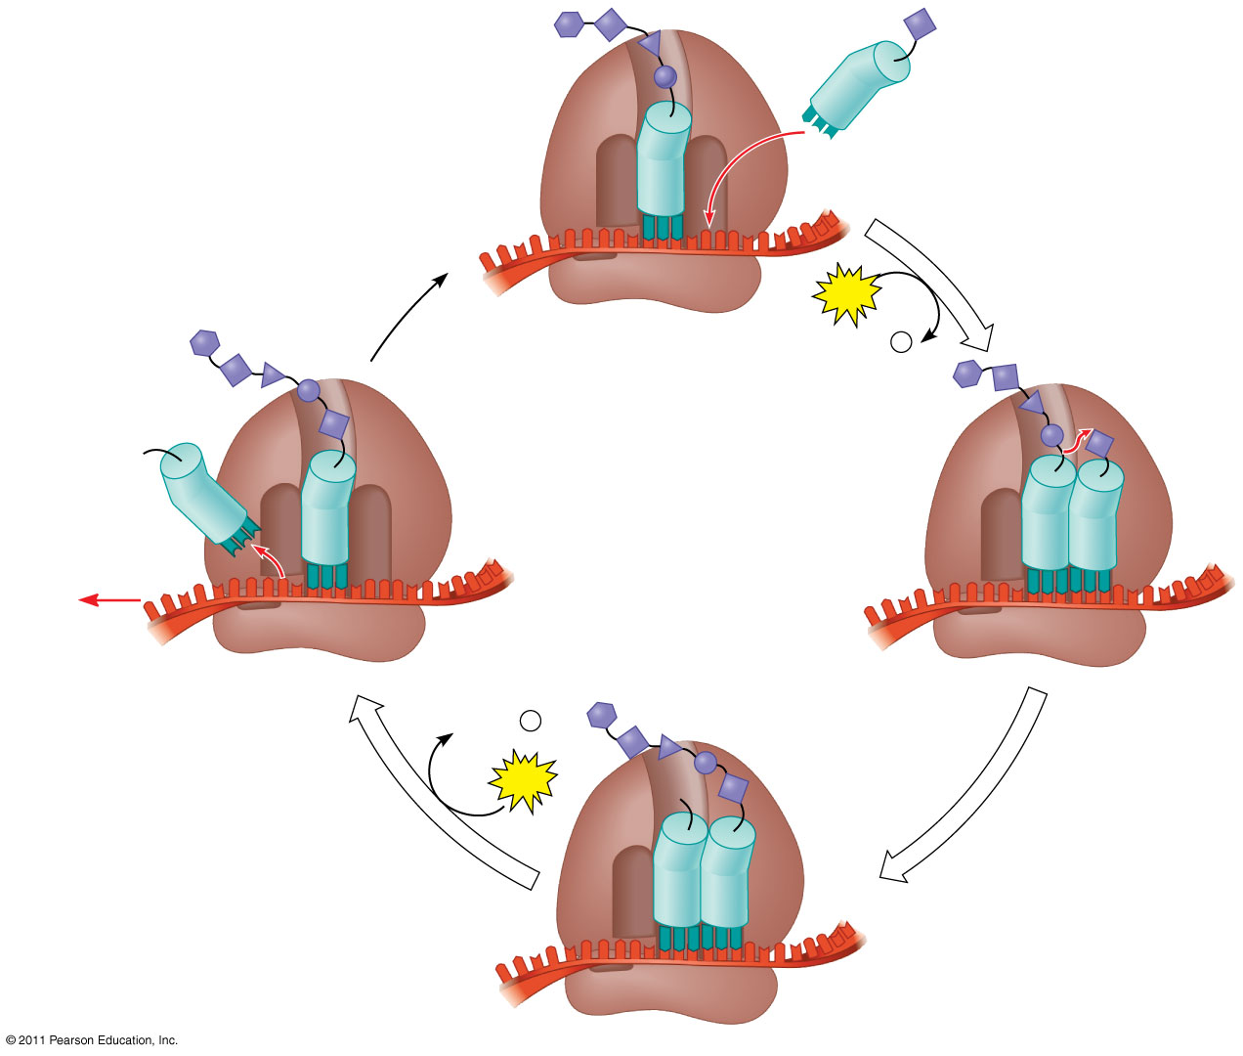

1. Use Figure 17.22 to explain how polypeptides are targeted to specific places (such as the Rough ER).

**Concept 17.5: Mutations of one or a few nucleotides can affect protein structure and function**

1. Describe the following types of mutations by summarizing how they alter the gene and impact the final amino acid sequence.

|  |  |  |
| --- | --- | --- |
| Type of Mutation | Impact on DNA | Impact on amino acid sequence |
| Nucleotide-par substitutions (point mutation) |  |  |
| Silent |  |  |
| Missense |  |  |
| Nonsense |  |  |
| Nucleotide-pair insertion or deletion (frameshift) |  |  |
| Nonsense |  |  |
| Missense |  |  |
| No frameshift/one amino acid missing |  |  |